

University of Science and Technology of Southern Philippines CDO Campus

May 17, 2024

A CONCEPT PROPOSAL

Development of a Web-based Document Management System for Barangay Kauswagan

Michelle Jean Arot, Erussha Mae Bangcoyo Alisha Nicole Salarda Kate Royce Ternate, Jarius Macalaguing

1. Background and Rationale

Barangay Kauswagan, nestled within the vibrant city of Cagayan de Oro, Misamis Oriental, Philippines, serves as a fundamental political unit crucial for community planning, organizing, and implementing public policies, programs, projects, and activities. Esteemed for its resilience and effective governance, Barangay Kauswagan plays a pivotal role in propelling local development efforts while nurturing strong community ties among its diverse population and rich cultural heritage.

Central to Barangay Kauswagan's commitment to enhancing residents' well-being is its dedication to inclusive governance principles and the execution of numerous programs aimed at enriching lives and fostering community engagement. By prioritizing the delivery of essential services, the barangay endeavors to elevate the quality of life for all its inhabitants, ensuring equitable access to opportunities and resources. Embracing digital innovations, the barangay recognizes the transformative potential of technology in streamlining operations and addressing the evolving needs of its residents (Aparici & Ruelan, 2018).

Despite the barangay's drive for progress and efficiency, a significant challenge arises within its administrative operations – the issue of time-consuming document management.

Reliance on traditional paper-based methods for storing and retrieving documents presents a notable obstacle for barangay officials. Manual processes, coupled with the substantial paperwork volume, slow down access to vital documents, including memoranda, office orders, directive orders, barangay resolutions, and ordinances. These time-consuming procedures not only require considerable resources but also increase the risk of errors or document misplacement, which can impact the timely resolution of community needs and decision-making processes for barangay officials.

In light of these challenges, Barangay Kauswagan is poised to explore innovative solutions leveraging technology to revolutionize its document management processes, ensuring accessibility, and efficiency in governance for its officials.

* 1. Statement of the Problem

This study aims to address the challenges associated with the traditional paper-based document management systems currently utilized in Barangay Kauswagan. Specifically, it seeks to explore the following:

Barangay Kauswagan's reliance on conventional paper-based methods for storing, organizing, and retrieving documents results in time-consuming administrative processes. Manual handling of documents slows down access to important materials such as memoranda, office orders, directives, resolutions, and ordinances. This manual process not only requires significant time and resources but also increases the risk of errors, misplacement, or loss of essential documents. These challenges may impede the ability of barangay officials to efficiently address community needs and make informed decisions.

Additionally, the absence of a centralized system disperses document repositories, posing challenges for coordination and collaboration among officials. Moreover, the frequency of document generation, with new documents being produced weekly, adds to the time- consuming nature of the current system.

* 1. Objectives of the study

To develop a comprehensive Document Management System (DMS) tailored to the specific needs and requirements of Barangay Kauswagan, with the aim of improving efficiency, organization, and accessibility of administrative documents and records.

* + - To design and develop a user-friendly and intuitive DMS platform that centralizes document storage, retrieval, and tracking, ensuring security, accessibility, and compliance with relevant regulations.
    - To implement the DMS in Barangay Kauswagan, providing necessary training and support to users to ensure successful adoption and integration into existing workflows.
    - To evaluate the effectiveness and impact of the DMS through feedback from users, performance metrics, and comparison with pre-implementation benchmarks, with the goal of continuous improvement and optimization.
    - To deploy the DMS in Barangay Kauswagan through a phased approach, beginning with pilot testing in select departments or functions, then gradually expanding to other areas, with a focus on minimizing operational disruption and maximizing user acceptance and adoption.
  1. Significance of the study

The comprehensive digitization of documents including memorandum, office orders, directive orders, barangay resolutions, and barangay ordinances within Barangay Kauswagan's administrative processes will yield numerous benefits for various stakeholders:

**Barangay Officials and Administrators.** Digitizing various documents including memoranda, office orders, directives, resolutions, and ordinances will streamline administrative operations, allowing officials to focus more on strategic planning and community development rather than paperwork. Enhanced accessibility to digital documents will enable informed decision-making, fostering streamlined governance. This study aims to improve record-keeping practices, ensuring historical data accessibility for continuity and accountability across administrations.

**Community Members and Citizens.** Although the website is primarily for the administration and officials of the barangay, its digitization of documents can still benefit residents. Increased transparency in decision-making processes fosters trust in local governance. Improved access to information keeps residents informed about community developments and decisions impacting their lives. Facilitated communication channels empower residents to express opinions and contribute to shaping the direction of the barangay, even if they are not directly involved in administrative tasks.

**Neighborhood Enterprises and Associations.** Digitizing documents will create an efficient business environment with reduced bureaucratic hurdles, fostering trust among businesses and stimulating investment. Enhanced transparency and accountability will promote collaboration between businesses, organizations, and the barangay government on initiatives benefiting the local community.

**Government Agencies and Partners.** Digitizing documents will align the barangay with national and regional e-governance and digital transformation initiatives. Standardized digital platforms will facilitate interoperability and data exchange among government agencies, promoting synergy in service delivery. Increased transparency and accountability will strengthen partnerships with government agencies, NGOs, and development partners, improving resource allocation for community development.

* 1. Scope and Limitation

The implementation of a Document Management System (DMS) at Barangay Kauswagan focuses on digitizing and optimizing document management processes within the barangay. Specifically, the DMS will handle various document types, including memorandums, office orders, directive orders, barangay resolutions, and barangay ordinances. Integration with the existing infrastructure will be prioritized to ensure seamless compatibility and operational efficiency. Extensive training will be provided to barangay staff to equip them with the necessary skills to utilize the system effectively. Additionally, comprehensive user manuals and detailed instructions will be furnished to facilitate the learning process.

Data migration efforts will be restricted to what is essential for the initial setup of the system. Any new document types or customizations beyond this scope will not be incorporated into the implementation. Additionally, the full implementation of this system is subject to subscription, and its availability will depend on the availability of funds allocated by the barangay. Any ongoing costs related to the system, such as subscription fees or additional support services, will be the responsibility of the barangay. Moreover, the researchers will exclusively utilize infrastructures available within Barangay Kauswagan for the implementation of the system.

1. Review of Related Literatures

These studies shed light on the significance and evolution of Document Management Systems (DMS) locally and internationally.

* 1. Local Studies

Belleza et al. (2020) emphasize the importance of implementing a document management and tracking system, highlighting its role in organizing, capturing, and storing business files and documents efficiently. Their discussion on the cloud-based document management software's secure central online repository connects with the central theme of digital document organization and retrieval.

Danlog et al. (2017) discuss the implementation of Computerized Record Management Systems (CRMS) in educational institutions, specifically focusing on enhancing the efficiency and security of student records. The emphasis on automated report generation and enhanced data security aligns with the objectives of digital document management.

Falolo et al. (2022) underscore the need for digital transformation in Student Registration and Records Management Services (SRRMS) within educational institutions. Their discussion on the reliance on manual processes and the importance of digital solutions resonates with the objectives of implementing DMS to improve efficiency and transparency in records management.

Delosa (2020) highlight the critical importance of implementing Records Management Systems (RMS) in healthcare settings, emphasizing the need for adherence to standards to enhance service quality. Their evaluation of the RMS at Cotabato Regional Medical Center emphasizes the role of technology in optimizing records management processes.

Cabalinan (2016) emphasizes the significance of Records Management Systems (RMS) in ensuring effective governance and accountability. The discussion on improving records management systems and policies aligns with the objectives of enhancing document management practices through digital solutions.

Medina et al. (2019) and Atanacio & Lacatan (2019) discuss the development and implementation of web-based information systems and the e-Barangay system, highlighting their role in enhancing local governance and organizational effectiveness. Their focus on tailored solutions and the utilization of software development methodologies connects with the theme of technological interventions for efficient data management.

Mukhtar et al. (2020) explore the Barangay Management System (eBarangay), emphasizing its transformational impact on barangay management. The discussion on employing software development methodologies such as prototyping aligns with the objectives of implementing digital document management systems to streamline administrative tasks.

Flores (2019) presents the Online Examination Portal as a web-based solution for automated examination processes, emphasizing its role in improving efficiency and eliminating the need for paper-based assessments. The discussion on the portal's automated approach connects with the theme of technological innovations in document management.

Martinez (2017) discusses digital technology platforms for citizen participation in local governance, highlighting their potential to increase transparency and accountability. While the focus is on citizen engagement, the discussion on software systems capable of managing services and records resonates with the objectives of implementing DMS for efficient document management.

* 1. International Studies

Document Management Systems (DMS) play a crucial role in modern office environments, facilitating efficient workflow management and information organization across various industries (Ugale, Patil, & Musande, 2017). Research by Ugale et al. emphasizes the significance of DMS in enhancing office operations, particularly through the development of an Online Document Tracking System (ODTS) tailored for the CIS Department of Universiti Teknologi Petronas, UTP. This system streamlines document- related processes, optimizing workflows and reducing paper consumption.

Similarly, Jalaludin (2014) underscores the importance of efficient document management systems in diverse industries. The implementation of an ODTS at Universiti Teknologi Petronas is noted for its potential to minimize workspace requirements and enhance operational efficiency.

Further highlighting the importance of effective document management, Juliet (2016) discusses the essential role of the Student Records Management System (SRMS) at Livingstone International University. This system not only centralizes student records but also ensures data security and efficient retrieval, contributing to administrative effectiveness.

Complementing the focus on document management systems, Ramalingam (2016) explores the benefits of Content Management Systems (CMS) in addressing challenges encountered in conventional website management approaches. CMS facilitates content organization and accessibility, aligning with the overarching theme of efficient information management.

In the context of business environments, Manikas (2016) delves into the implications of implementing Electronic Document Records Management Systems (EDRMS). Through qualitative research, the study examines perceptions of efficiency and associated costs, shedding light on the experiences of individuals within organizations utilizing EDRMS.

Transitioning from traditional paper-based systems to paperless environments presents significant opportunities for enhanced efficiency and productivity (Chao, 2015).

Despite the advantages offered by paperless systems, many organizations, especially small and medium-sized businesses (SMBs), continue to operate within paper-centric environments. Chao's research underscores the need for further investigation into the obstacles hindering the adoption of paperless systems.

The contributions of Lutteroth et al. (2011) and Selvi et al. (2011) shed light on the broader implications of transitioning to paperless office setups. These studies emphasize the importance of electronic technologies, such as Document Management Systems (DMS), in modernizing office environments and increasing productivity.

Building on this, Sternad Zabukovšek et al. (2020) discuss the integral role of DMS in digital transformation efforts within organizations. DMS facilitates workflow automation and enhances information security, aligning with the broader theme of optimizing organizational efficiency.

Zebec's (2010) historical exploration of DMS evolution provides valuable insights into the continuous development of document management technologies. This evolution, characterized by advancements such as Document Imaging Processing (DIP), underscores the transformative impact of technology on document management practices.

Finally, Biels (2021) traces the historical evolution of document management practices, highlighting the transition from traditional to digital systems driven by technological advancements. This historical perspective contextualizes the contemporary significance of efficient document management in organizational processes.

System Architecture

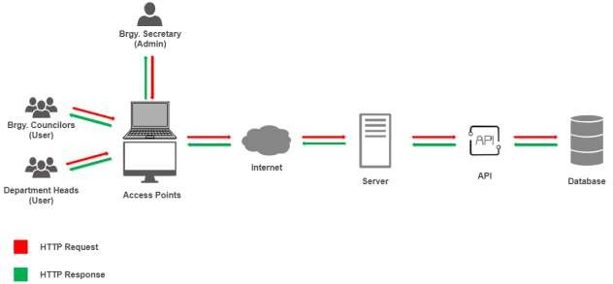

Technology Stack

The researchers have opted to utilize HTML, CSS, and Javascript for front-end development in their capstone research project. PHP will be employed as the programming language on the back end, with Laravel serving as the chosen framework and MySQL as the database management system. This comprehensive technology stack, coupled with the Ubuntu server, will empower the researchers to develop a robust and efficient web-based system for digitizing resolutions in Barangay Kauswagan, ensuring seamless functionality and optimal performance.

Gantt Chart

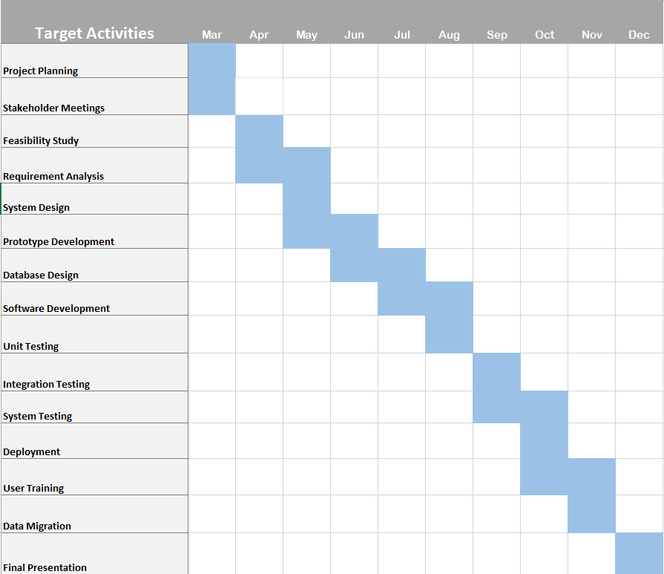

Reference

“Batas Pambansa Blg. 337, (1983-02-10),” lawyerly.ph. https://lawyerly.ph/laws/view/l44b0 (accessed Jun. 13, 2022).

R. J. S. Medina, L. A. C. Separa, L. J. Generales, & S. S. D. Reyes, “Moving Towards Technology-Based LGUs: A Review of Computer Literacy of Mariveles Barangays,”

International Journal of Sciences: Basic and Applied Research, vol. 33, no. 1, pp. 218-226, 2019.

M. L. Atanacio, and L. L. Lacatan, “Development and evaluation of Rural Health Unit Record Management System with data analytics for Municipality of Bay, Laguna using ISO 25010,” International Journal of Recent Technology and Engineering, vol. 8, no. 3, pp. 3915– 3919, 2019.

M. Mukhtar, S. Sudarmi, M. Wahyudi, & B. Burmansah, “The Information System Development Based on Knowledge Management in Higher Education Institution,” International Journal of Higher Education, vol. 9, 2020.

R. Flores, “Assessment of Selected Barangays in Makati City Towards Improved Barangay Governance. Iapa Proceedings Conference, pp. 141- 167, 2019.

Martinez, H. (2017). Practitioner reflections on digital technologies and citizen participation in the Philippines. Retrieved from [https://www.makingallvoicescount.org/blog/practitioner-](https://www.makingallvoicescount.org/blog/practitioner-reflections-digital-technologies-citizen-participation-philippines/) [reflections-digital-technologies-citizen-participation-philippines/](https://www.makingallvoicescount.org/blog/practitioner-reflections-digital-technologies-citizen-participation-philippines/)

Chao, C. (2015). Implementing A Paperless System for Small and Medium Businesses

Lutteroth, C. & Weber, G. (2011). Going paperless - on the evaluation of electronic form technologies.” In 2012 23rd International Workshop on Database and Expert Systems Applications. IEEE Computer Society, 14–18. <http://doi.ieeecomputersociety.org/10.1109/DEXA.2011.38>

Sternad Zabukovšek, S., Tominc, P., Štrukelj, T., & Bobek, S. (2020). Digitalna

transformacija in poslovne informacijske rešitve. Great Britain: Pearson Education.

Docxellent. (2019). The Benefits of Going Green with Electronic Document Management Software. Retrieved from https://info. docxellent.com/blog/benefits-of-going-green-with- document-management-software.

Zebec, A. (2010). Elektronski sistem za upravljanje z dokumenti. Ljubljana: Ekonomska fakulteta.

Biels document management. (2021). A history of Document Management. Retrieved from https://instreamllc. com/a-history-of-document-management/

Ugale, M. K., Patil, S. J., & Musande, V. B. (2017). Title of the Paper. In 2017 1st International Conference on Intelligent Systems and Information Management (ICISIM).

Jalaludin, M. N. A. (2014, September). Online Document Tracking System.

Manikas, K. (2016). Records Management and Electronic Records Management Opportunities and Limitations: A case study in Greek companies.

Juliet, N. (2016). Student Record Management System: A Case Study of Livingstone International University in Mbale (Uganda).

Ramalingam, E. (2016). Research paper on Content Management Systems (CMS): Problems in the Traditional Model and Advantages of CMS in Managing Corporate Websites.

Belleza, N., Adufina, C., Banaag, H., Patotoy, I., Revamonte, S. J., & Cacho, D. (2020, March). Document Management System and Document Tracking System.

Danlog, K. P. P., Rebujio, E. C., De Guzman, P. A., Arrieta, K. I. S., & Carranza, B. D. (2017). Computerized Record Management System of Quetegan National High School.

Falolo, V. M., Capillas, K. T., Vergarra, N. A., & Cerbito, A. F. (2022). Student Registration and Records Management Services towards Digitization.

Delosa, S. A., & Delosa Jr., R. A. (2020). Implementation of Records Management System in Cotabato Regional Medical Center Health Information Management Department.

Cabalinan, E. J. C. (2016). Records management and archival practices at Central Philippine University.